Using your chromebook to do your homework

Step 1 – Installing Word and Powerpoint

Step 2 – Setting Word as default

Step 3 – Downloading homework from Class Charts

Step 4 – Sign in to Word

Step 5 – Save a copy to One Drive

Step 6 – Download your finished work from One Drive

Step 7 – Upload your finished work to Class Charts

Step 1

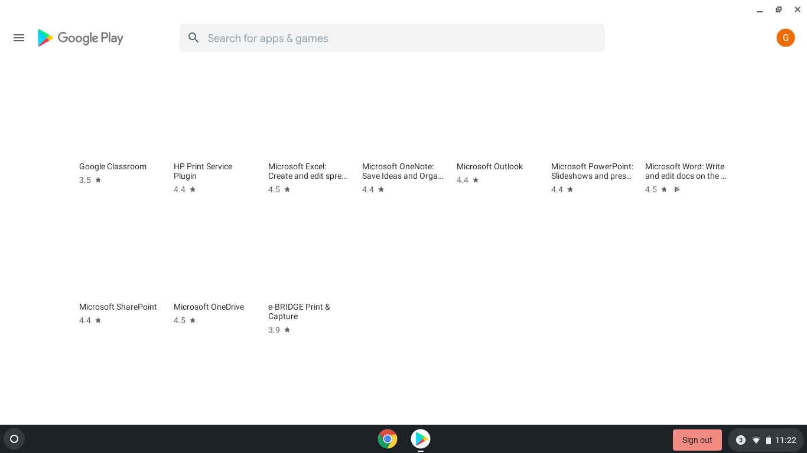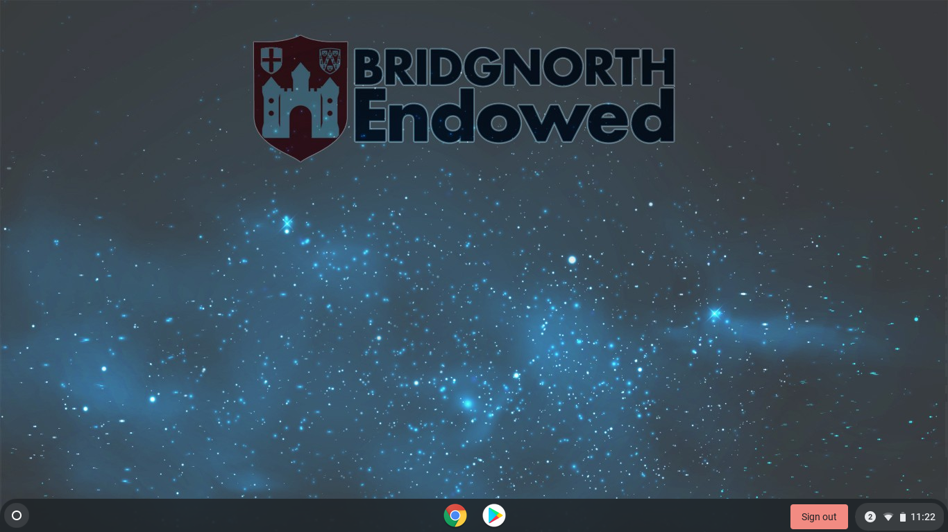

Find Microsoft Word and Microsoft Powerpoint and click on them

Click on the white icon with a triangle to open the Play Store

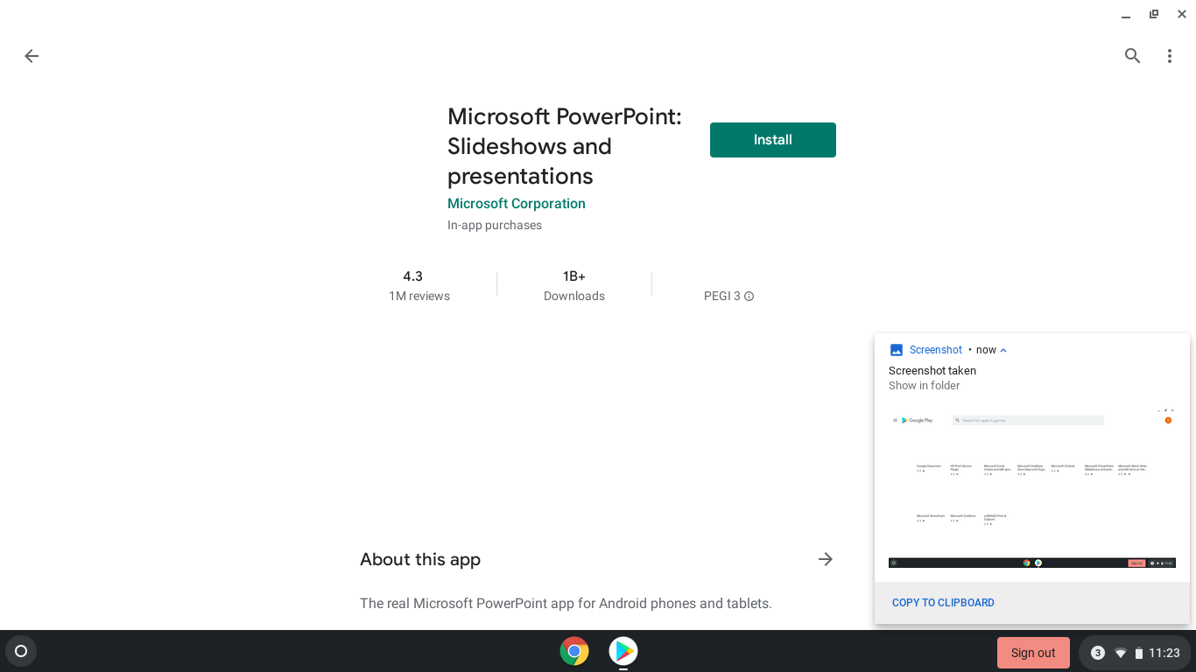

Click on Install

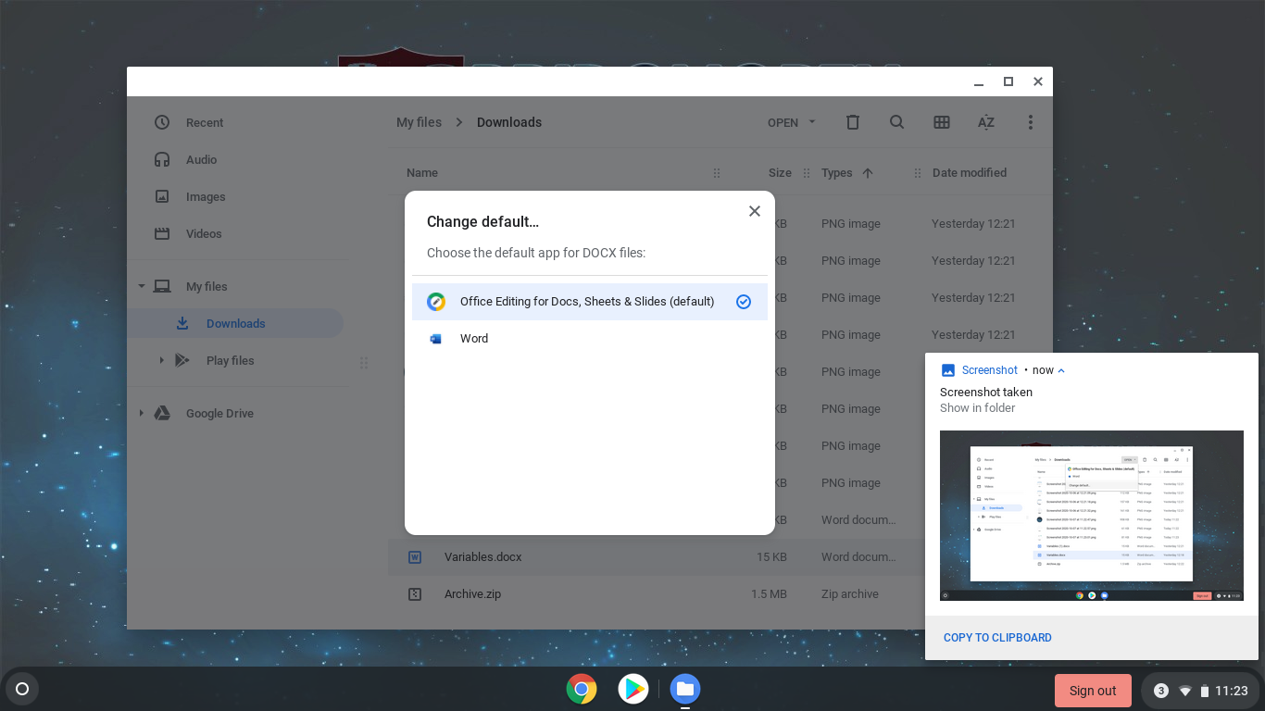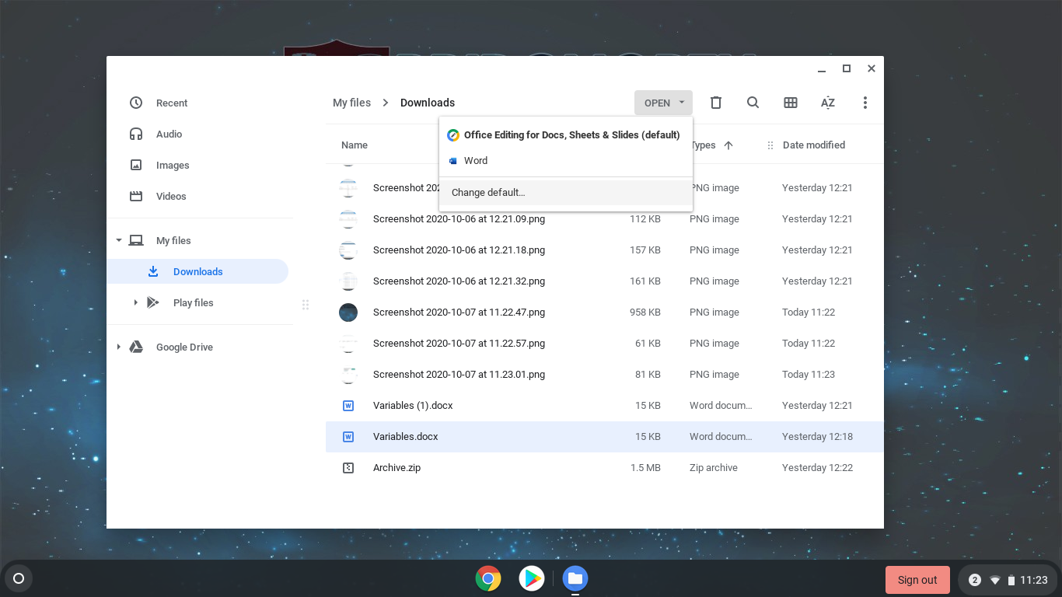

Step 2

Click on Word to make it the default program. Now you can double click on a document and it will open straight into Word.

You will need to do the same for Powerpoint as well.

Now we can set Word as the default program. Click once on a Word document in your downloads folder then click on the OPEN button.

Then click on Change default…

Step 3

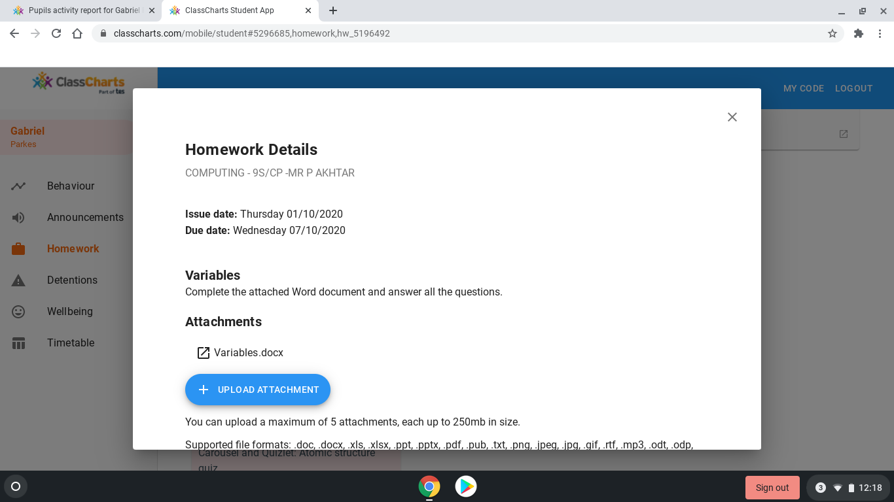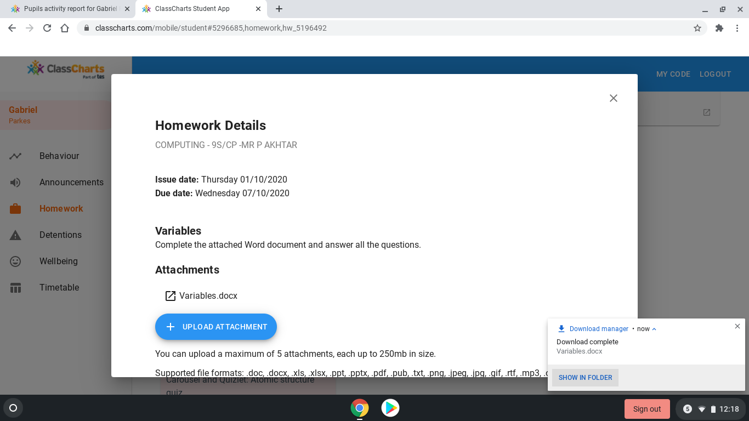

Click on the work you want to **download** from **ClassCharts** (in the screenshot it is called Variables.docx)

Once you’ve downloaded it you can see a pop up in the bottom right. Click on **Show in folder** to open your Downloads folder

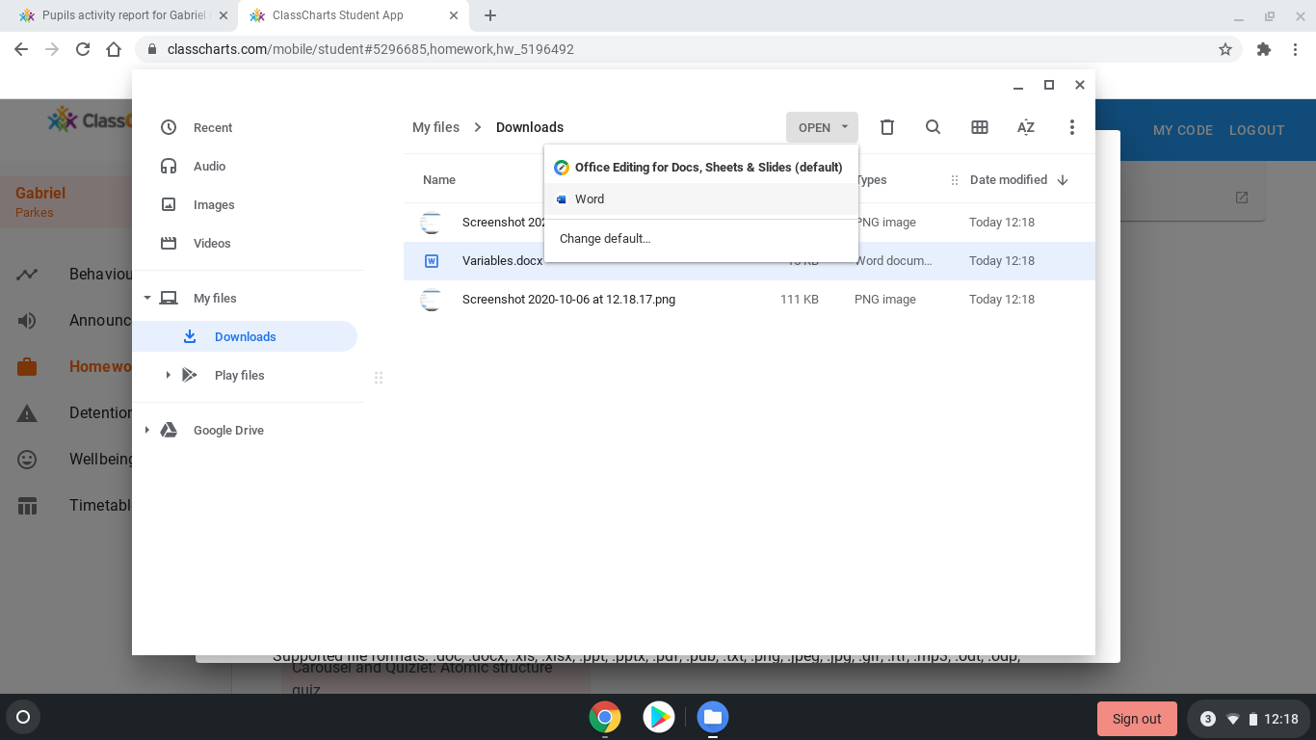

Find your homework then click on it once. Then click on the **Open** button and choose Word. (You can set Word to be the default program by clicking Change default…)

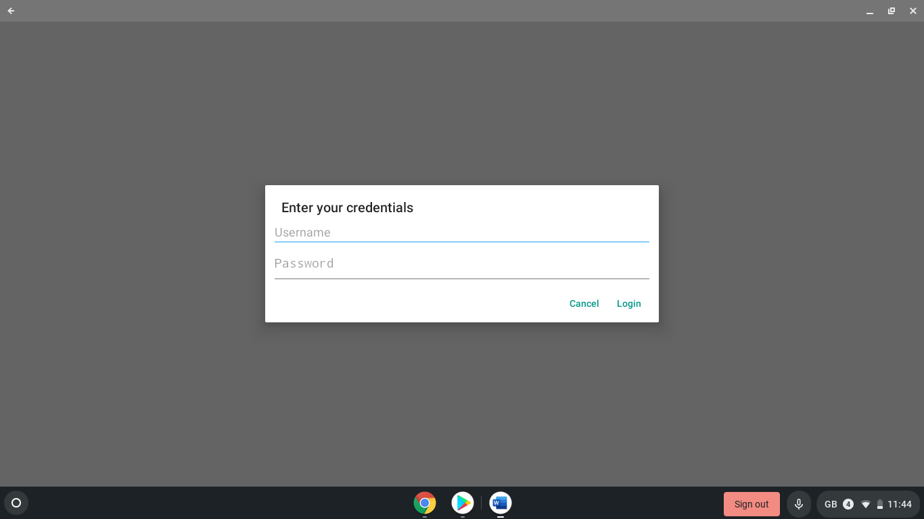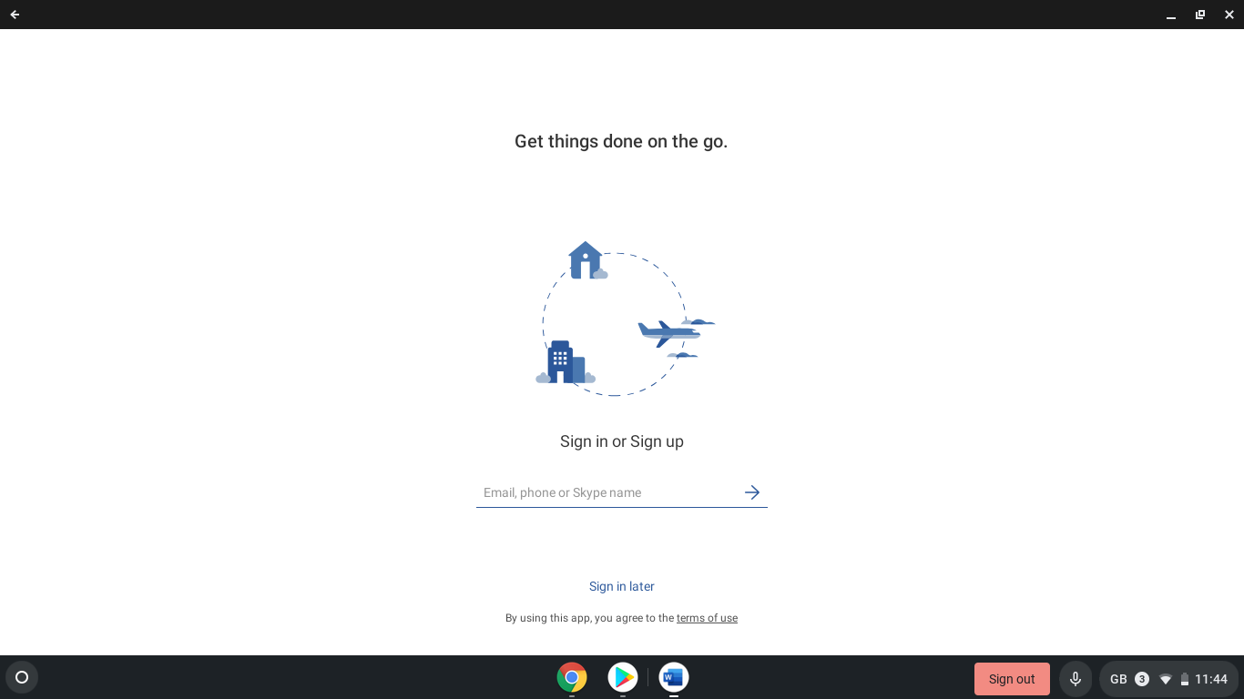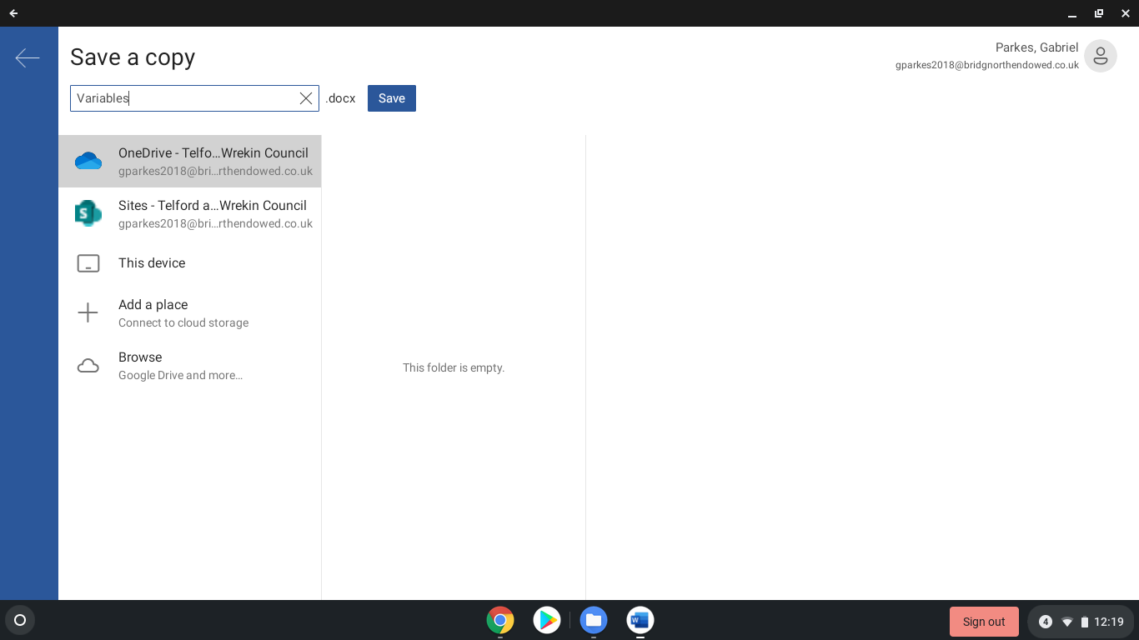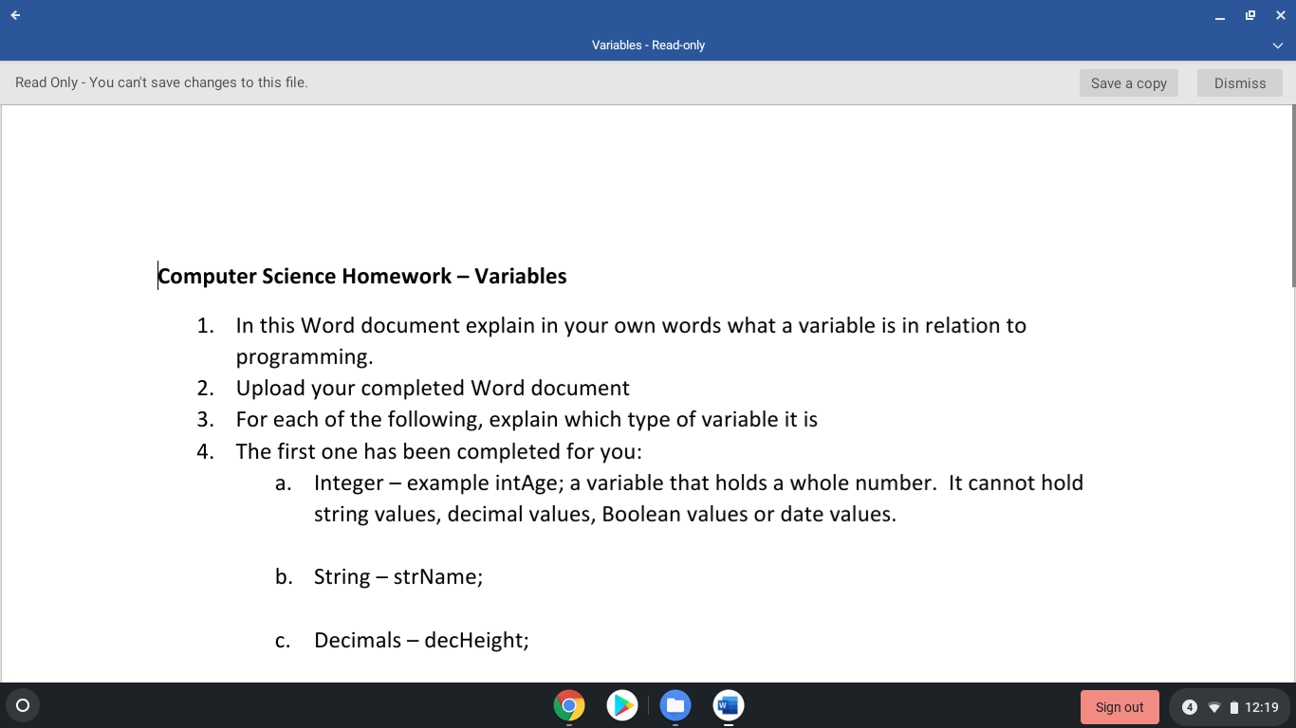

It will ask you to sign in one more time – you just need to put your school username and password in

When you first open Word you’ll need to sign in using your school email address (which is your [username@bridgnorthendowed.co.uk](mailto:username@bridgnorthendowed.co.uk)) and your school password

Step 4

The first option when you click on Save will be **OneDrive**. Click on **OneDrive** then choose the correct folder. **Name your document something that makes sense and then click Save.**

As you work Word will auto save your work to your OneDrive. Once you have finished you will need to **download** your finished work **from** your **OneDrive** so you can **upload** it to **ClassCharts**.

Click on the **Save a copy** button.

Step 5

Step 6

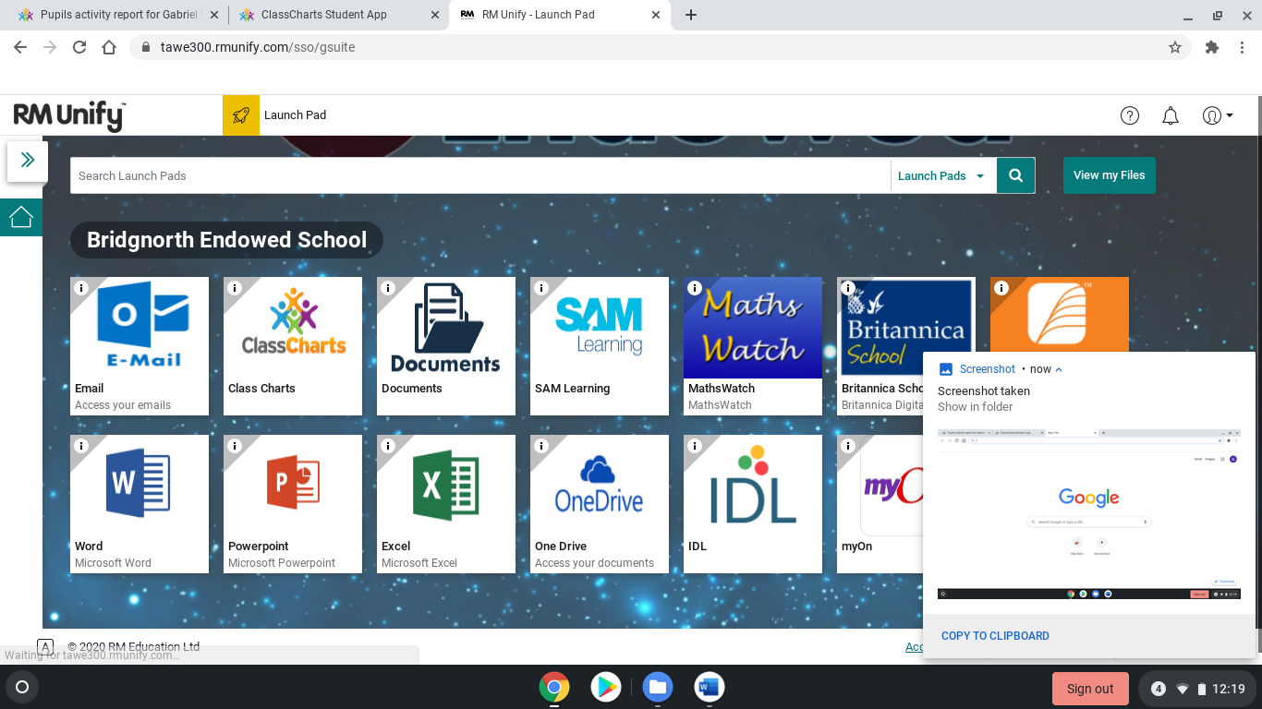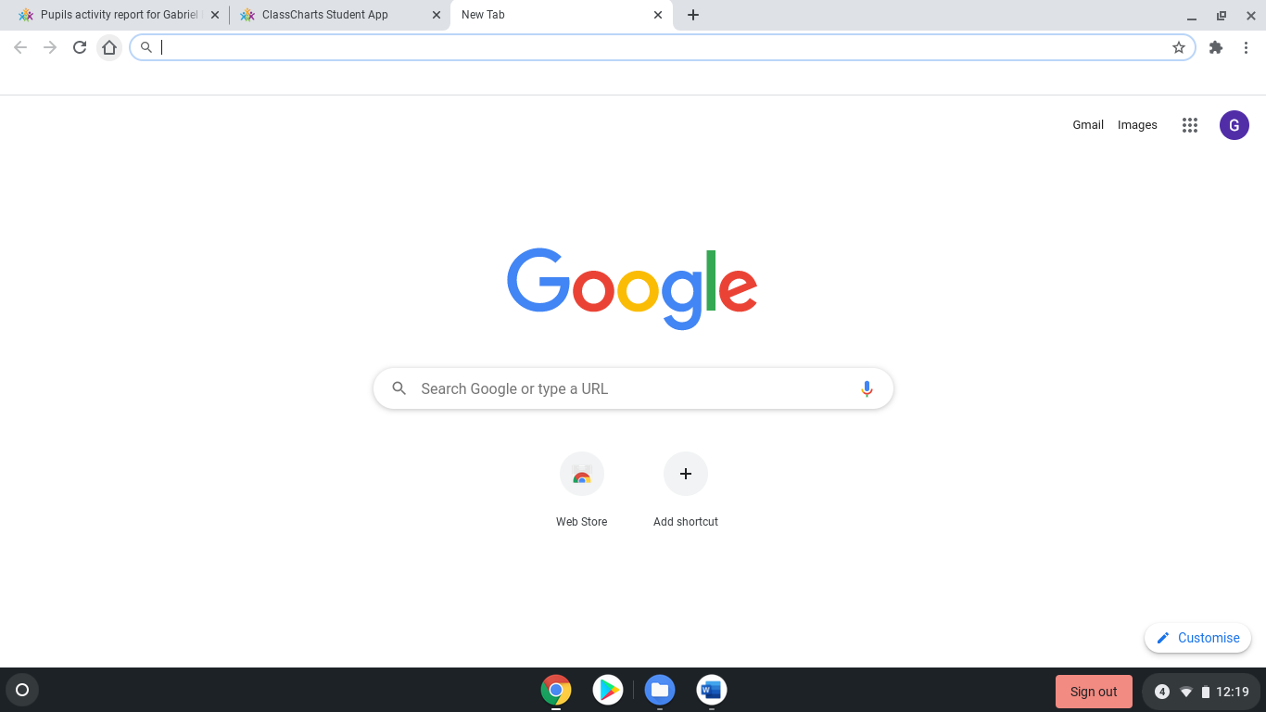

RM Unify should log you in automatically. If it doesn’t you can log in using your school email and password. Once you are logged in click on the One Drive button

Click on the Google Chrome icon (the first on the left at the bottom) then click on the little house button next to where you type the web address. This will take you to RM Unify

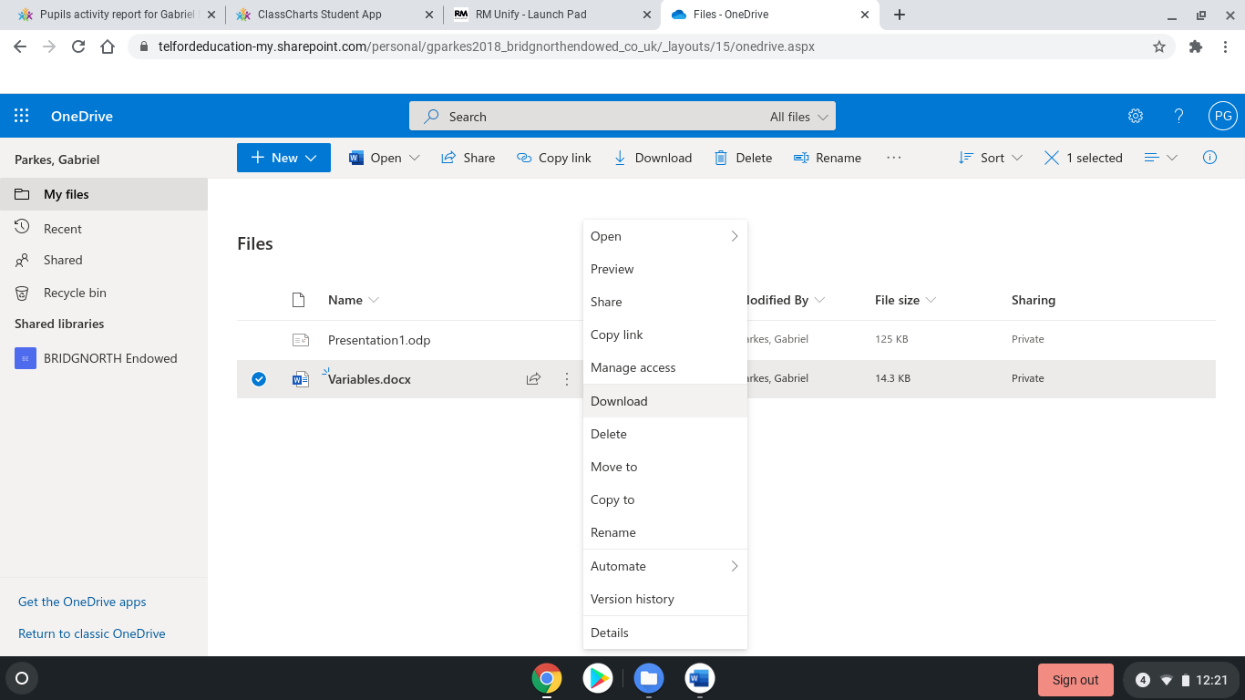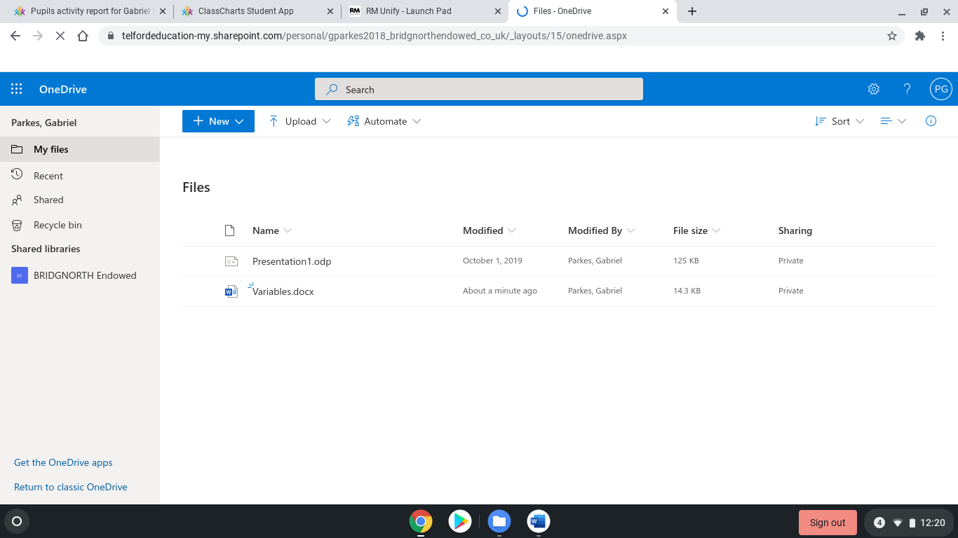

Click on **Download**

Find your work in where you saved it in your OneDrive. Click on the 3 dots next to the filename.

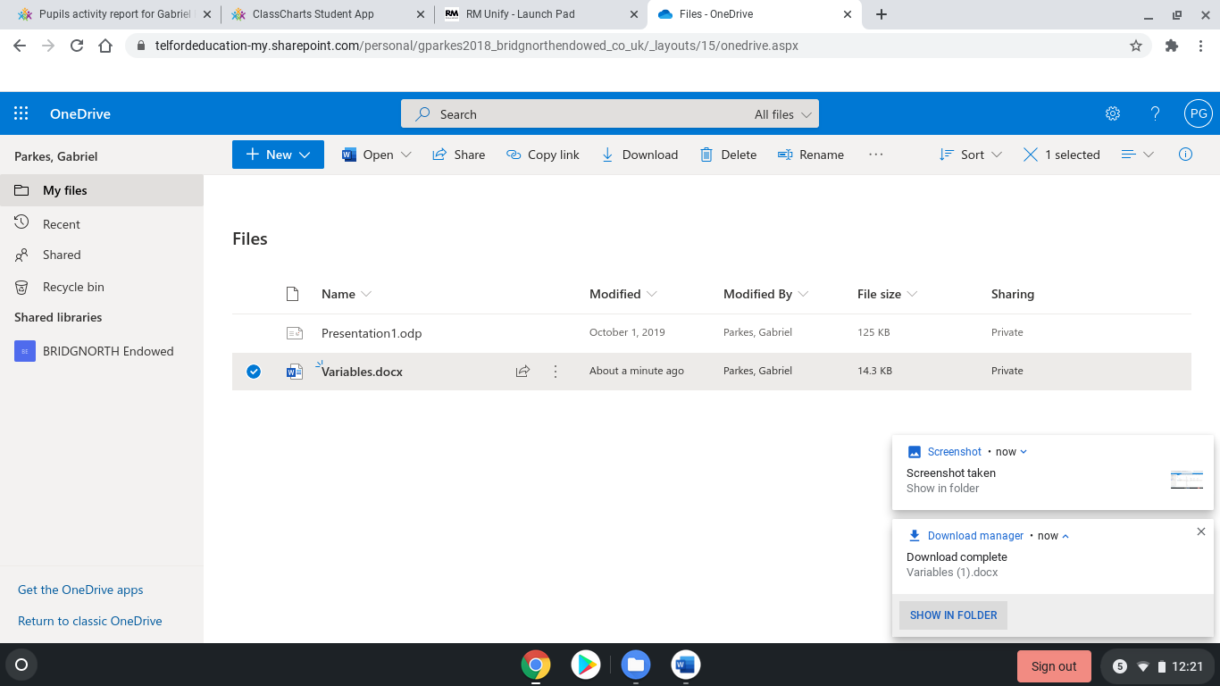

Once you’ve clicked Download, you’ll see the pop up in the bottom right again. Click on **Show in folder** to open the downloads folder and make sure you can see your work

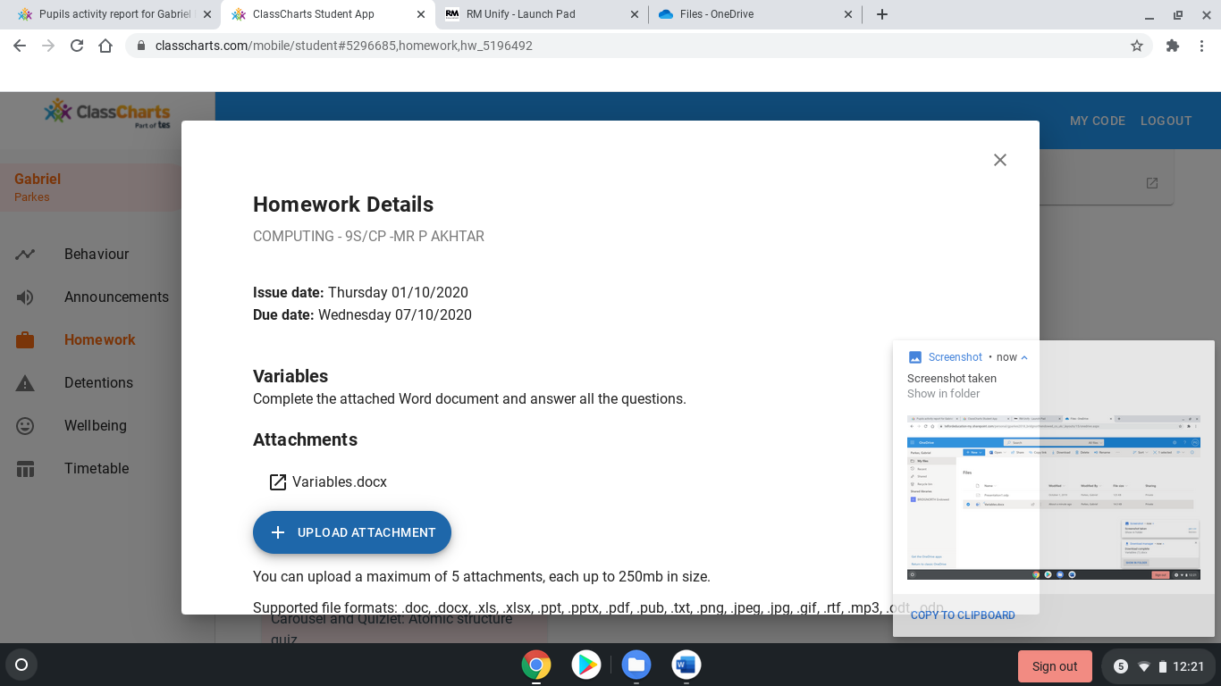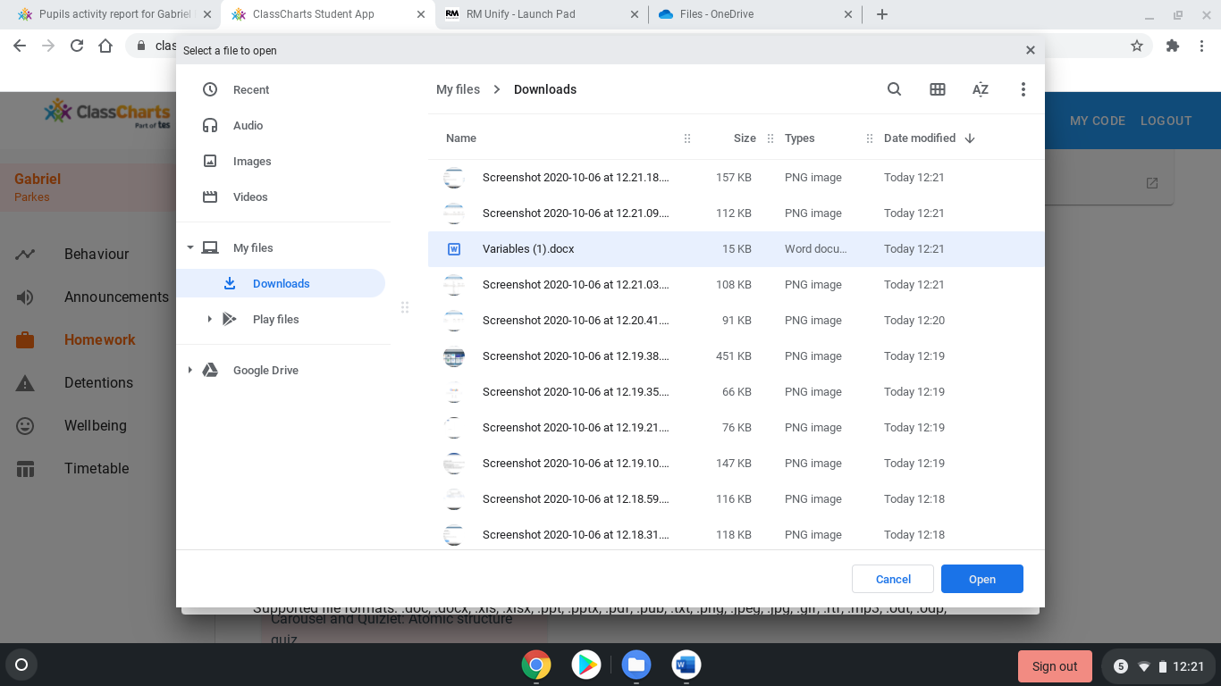

Step 7

Go back to ClassCharts and click **Upload** Attachment.

Find your work and **click on it** then click **Open** to finish the upload to ClassCharts.